
Garden Tour
Sunday June 28, 2026
12:30pm to 4:30pm – rain or shine
Admission: CASH donation to the
Centre Wellington Food Bank
Brochures are available at | Garden Addresses
LittleTree Garden Market | 74 Duncan Court, Fergus
Victoria Park Seniors Centre | 125 St. George St. East, Fergus
Elora Information Centre | 725 Dianne Crescent, Fergus
Fergus & Elora Public Libraries | 495 Anderson St. South Fergus
Sportsplex | 319 South River Road, Elora
I Love Chocolate
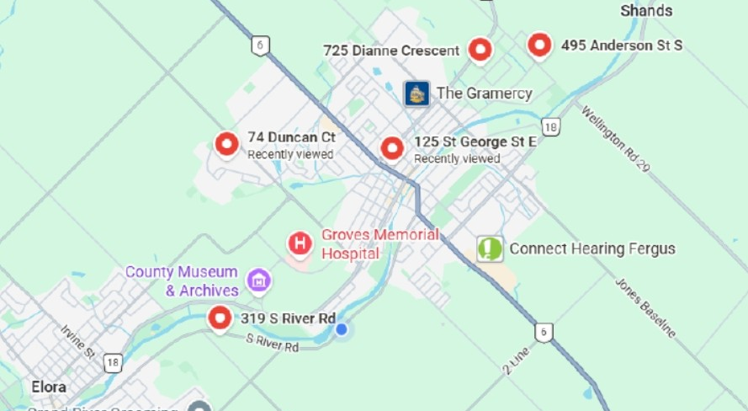

 | For further information: www.fergushorticulture.com or email us at fergushorticulture@gmail.com

