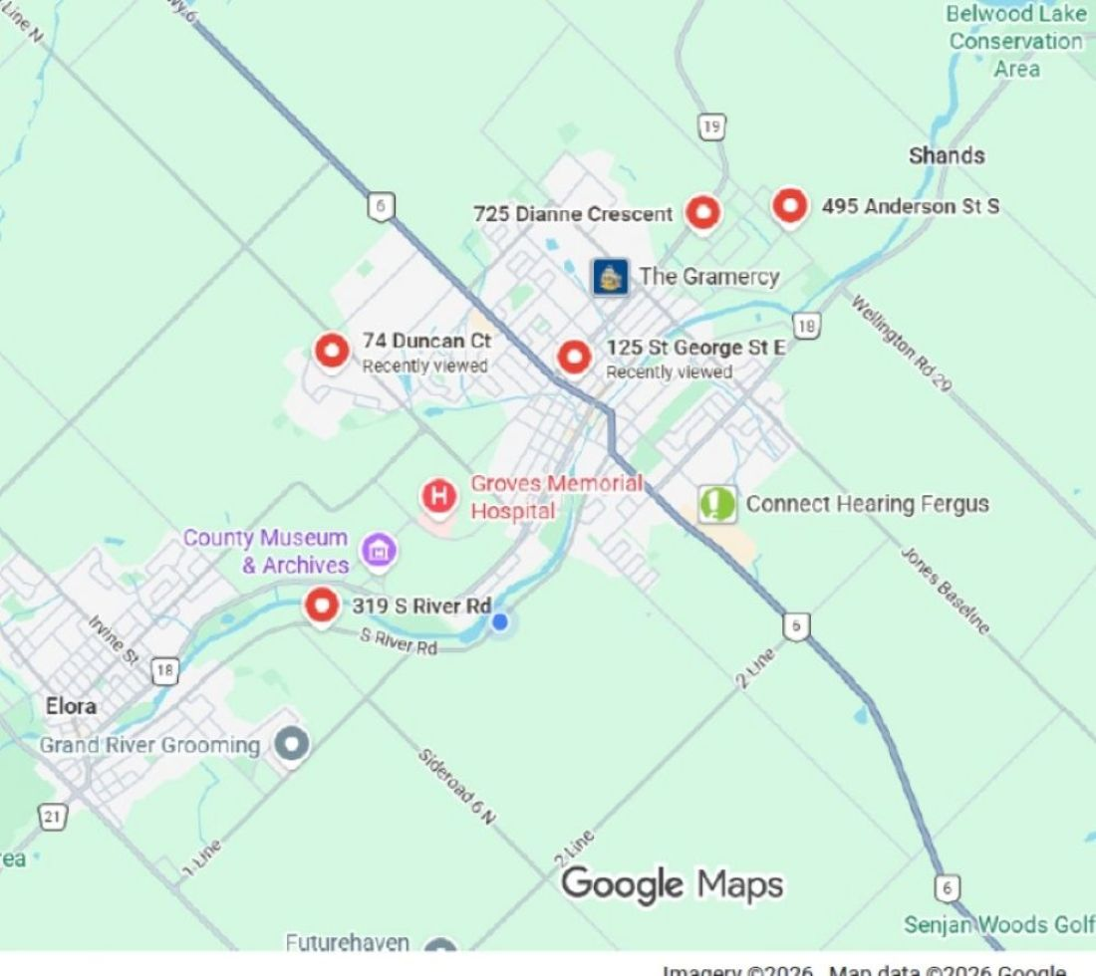


2026 Garden Tour
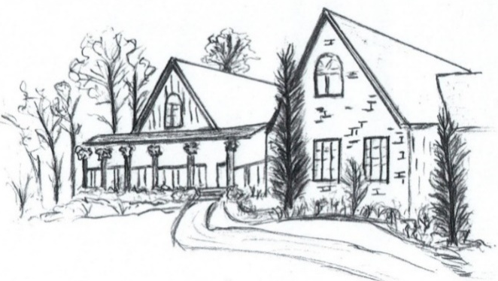

Image created by Joan Cuming

Sunday June 28, 2026
12:30 to 4:30 - rain or shine

Admission by CASH donation for the
Centre Wellington Food Bank

Garden Tour Locations
74 Duncan Court, Fergus
125 St. George St. East, Fergus
725 Dianne Crescent, Fergus
495 Anderson St. South Fergus
319 South River Road, Elora

Website: fergushorticulture.ca
Email: fergushorticulture@gmail.com

The Fergus & District Horticultural Society is proud to present the 2026 Annual Garden Tour, a celebration of nature's artistry and the dedication of passionate gardeners. This year, the tour will feature five beautifully curated home gardens, each a testament to the creativity and love of their owners Visitors will have the opportunity to explore serene spaces, marvel at diverse plant varieties, and gain inspiration for their own gardening endeavours.
74 Duncan Court, Fergus
The owners built this property 9 years ago. Gardens wrap around the entire perimeter of the house, with one of the side gardens being only a year old. The property contains both sun and shade gardens, with perennials planted in the ground and in boxes. Annual flowers and vegetables are grown in the garden and in planters, adding colour and interest. In the back is a large raised deck with many stairs, and the entire area is decorated with planters.
125 St. George St. East, Fergus
15 years ago, the current owners inherited the original garden design when they moved into this home, built in 1856. They have continued to evolve the gardens over time, adding their own touches. Out back are 2 water features, while the front of the property is dominated by a grove of Norway Spruce trees, providing year round shade and cover. You feel like you are taking a walk through the woods and discovering an ancient ruin.
725 Dianne Crescent, Fergus
This family home on a 0.6 acre lot was built 30 years ago by the current owners. Using a blank canvas, the plan was to frame the house and property with trees, shrubs and gardens, while retaining as much open space as possible. Low maintenance plantings were selected to keep the property manageable, while ensuring a continuous display of colour throughout the growing season. A pool and accompanying structures were added in 2020. The backyard includes raised vegetable beds, and everbearing raspberries. Overall the property combines a functional outdoor living space with the beauty of nature.
495 Anderson St. South, Fergus
The current owner moved to this ¾ acre property in 1999, transforming it over time to a small farm focusing on organic flowers and seeds. A 45 foot greenhouse and a 2-story shop support this small floral business focusing on dahlias and specialty plants. Don’t expect a show perfect home garden as this is a working small farm, maintained by one person. The landscape is anchored by native trees and shrubs complemented by perennials and annuals. Some are integral to the floral business while others simply contribute to the health, diversity and beauty of the garden ecosystem. This property is not usually open to the public. Visitors are welcome to enjoy this opportunity to explore a living working farm shaped by time, seasons and a deep connection to the land.
319 South River Road, Elora
This half-acre property is characterized by a pine and spruce tree stand on sandy soil. The gardens and landscape have been developed over the last 20 years, with primarily shade tolerant perennials focusing on texture. Annuals provide a pop of colour. Shrubs and small trees provide vertical interest. Birds are encouraged through nesting boxes and feeders, providing a relaxing, retreat-like atmosphere. Since the owners are involved with plant health and pathology, in jest they often say they know the diseases and insects in their gardens better than they know their plants.

